# JUCE DJ App Manual

Table of contents

JUCE DJ App Manual 1

Introduction 2

Basic functionality (R1) 2

R1A: can load audio files into audio players 2

Can play two or more tracks 3

Can mix the tracks by varying each of their volumes 4

Can speed up and slow down the tracks 4

Implementation of a custom deck control Component with custom graphics which allows the user to control deck playback in some way that is more advanced than stop / start. 4

Component has custom graphics implemented in a paint function 4

Component enables the user to control the playback of a deck somehow 5

Implementation of a music library component which allows the user to manage their music library 5

Component allows the user to add files to their library 5

Component parses and displays meta data such as filename and song length 5

Component allows the user to search for files 6

Component allows the user to load files from the library into a deck 6

The music library persists so that it is restored when the user exits then restarts the application 6

Implementation of a complete custom GUI 6

GUI layout is significantly different from the basic DeckGUI shown in class, with extra controls 6

Summary 9

Custom Knobs: <https://github.com/remberg/juceCustomSliderSample>

Colors: <https://www.ccoderun.ca/programming/doxygen/juce/namespacejuce_1_1Colours.html>

## Introduction

OtoDecks is a desktop DJ application written in C++ leveraging the JUCE Framework, which offers ready-made, customizable (GUI and audio related) components that are perfect for our use case.

The application allows to:

* Import tracks from the user’s computer to the application playlist
* Save the playlist so that it is reloaded as saved even if the app is closed and reopened
* Load a track to the left deck and control it autonomously. Load a track to the right deck and control it autonomously.
* Play two tracks simultaneously and control their speed, volume, track position, and reverb properties through intuitive GUI components such as knobs and sliders.

This application was developed as final project for the class of Object-Oriented Programming and thus the different application components are divided into a series of header and .cpp files, following the best practice of separation of concerns. Code documentation can be found for each function within the header files (following [these guidelines](https://developer.lsst.io/cpp/api-docs.html)).

This is how the application looks like:

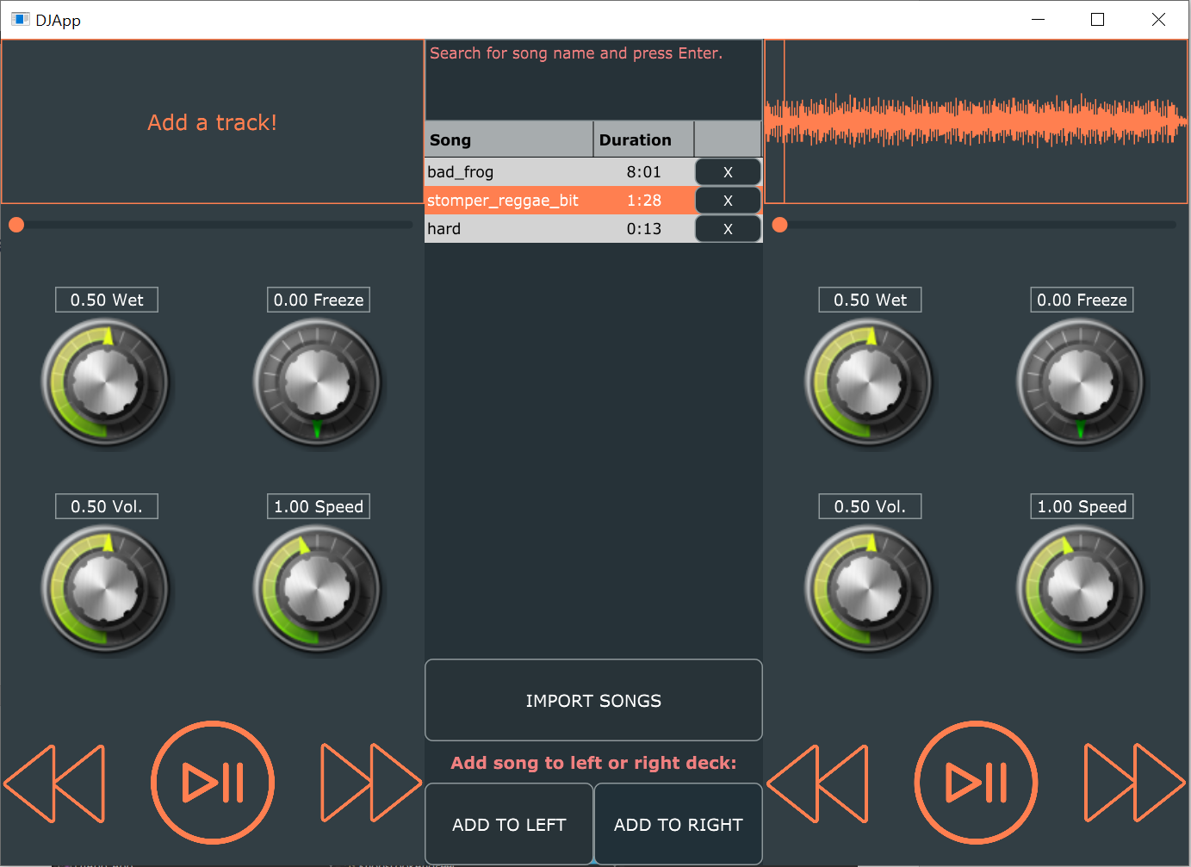

Figure 1 - App appearance

In this report I will describe the structure of the application, highlighting how its features were implemented.

## Basic functionality (R1)

OtoDecks contains all the basic functionality shown in class: R1A, R1B, R1C, and R1D. Below is a detailed description for each requirement implementation.

### R1A: can load audio files into audio players

When the user clicks on the ‘Import songs’ button, the function ‘buttonClicked’ within file ‘PlaylistComponent.cpp’ is called.

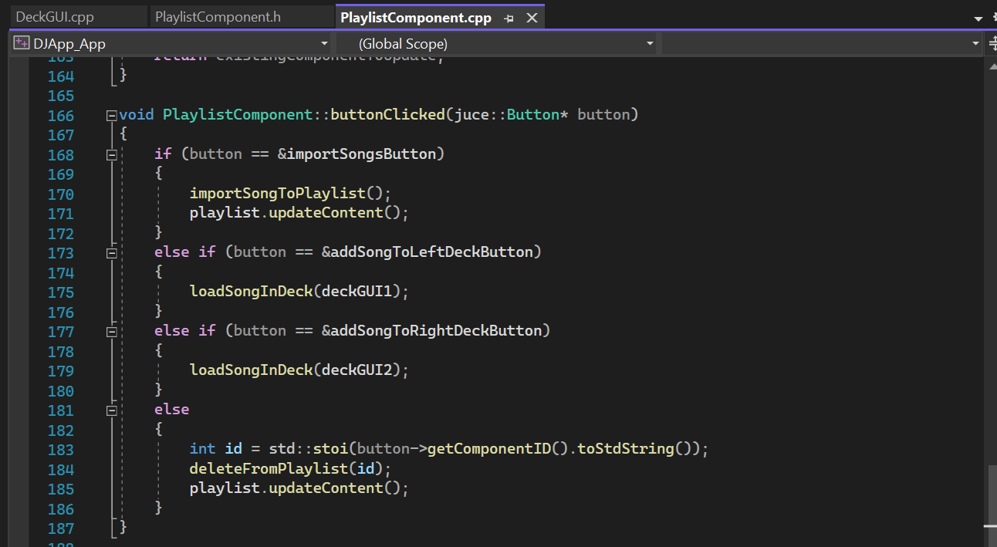

Figure 2 - PlaylistComponent::buttonClicked()

Here, we detect what button was clicked and call different logic accordingly. In this case, the condition at line 168 is met and function ‘importSongToPlaylist()’ is called. After this, the content of the playlist is updated to include the new song.

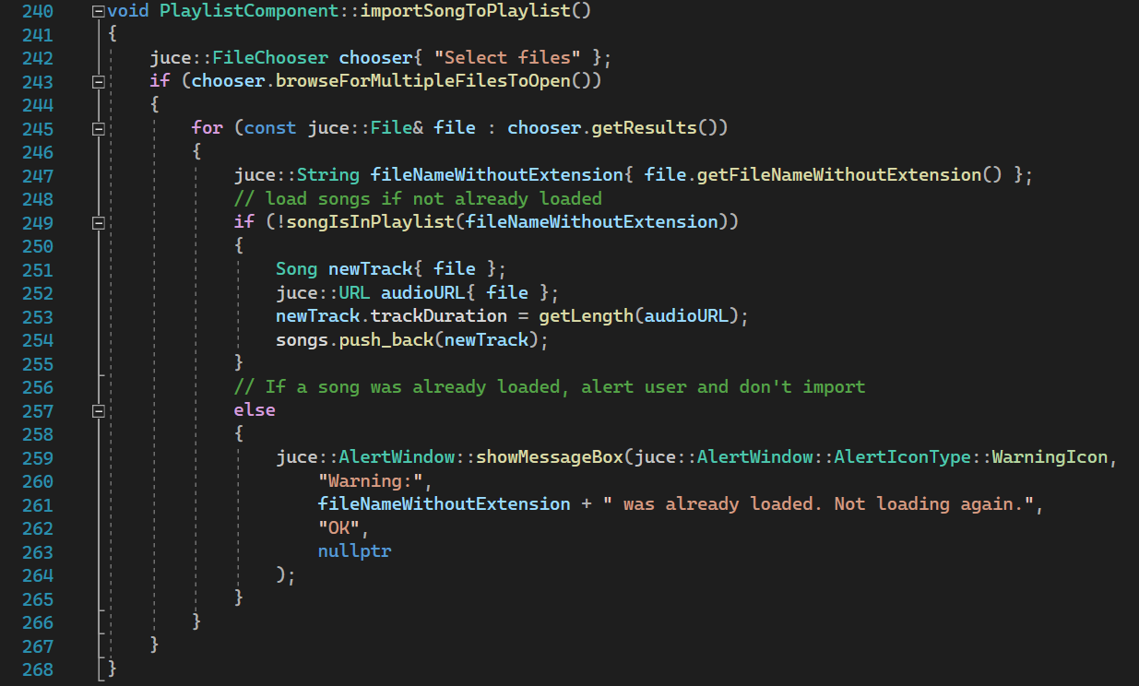

Figure 3 - PlaylistComponent::importSongToPlaylist()

Here, the logic allows the user to browse and select multiple files. If the selected song is not already loaded in the playlist, class juce::URL allows us to load the audio file, while at line 251 an object of class Song is created and then added to the playlist at line 254.

The Song class contains a constructor (l. 26), called every time a new song is added to the playlist public properties: songName, trackDuration, file, URL, and a Boolean operator used to compare song names.

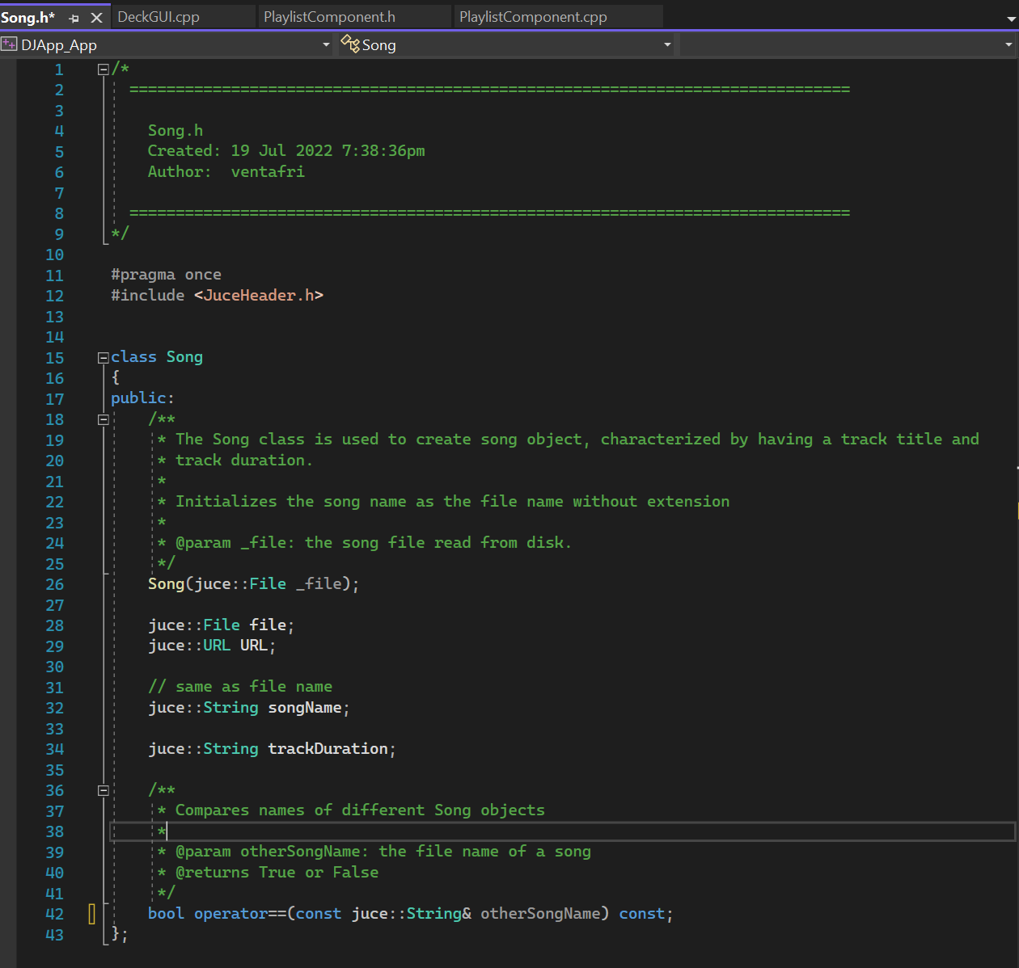

Figure 4 - Song class .h

Once the song is in the playlist, the user can select it by clicking on it and then click on buttons ‘Add to left’ or ‘Add to right’ to add the song to the left or right deck respectively. Clicking on ‘Add to left’ or ‘Add to right’ triggers the call of function ‘loadSongInDeck()’ (Figure 2, line 175 or 179), which actually loads the song to the selected deck (left or right), at line 226.

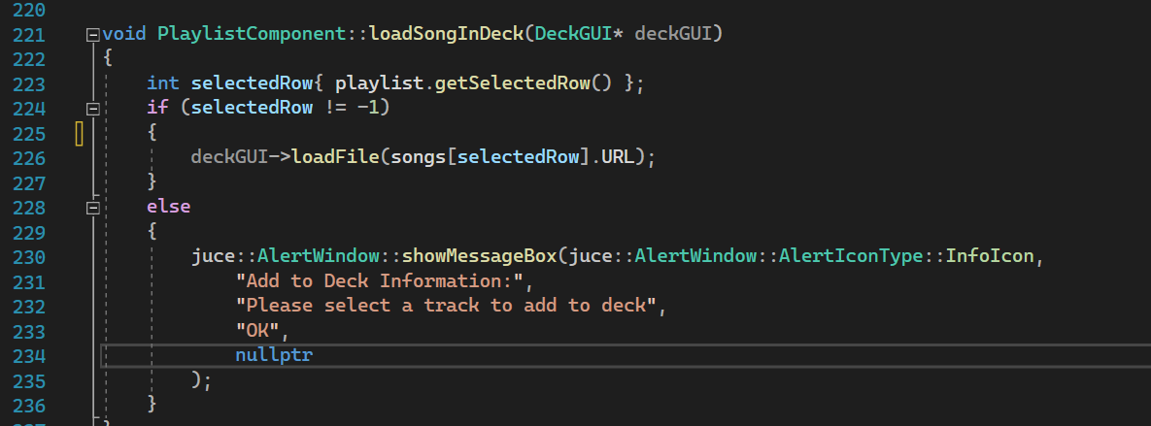

Figure 5 - PlaylistComponent::loadSongInDeck(DeckGUI* deckGUI)

Calling DeckGUI::loadFile has the effect of drawing the waveform of the song onto the selected deck. The song can now be played.

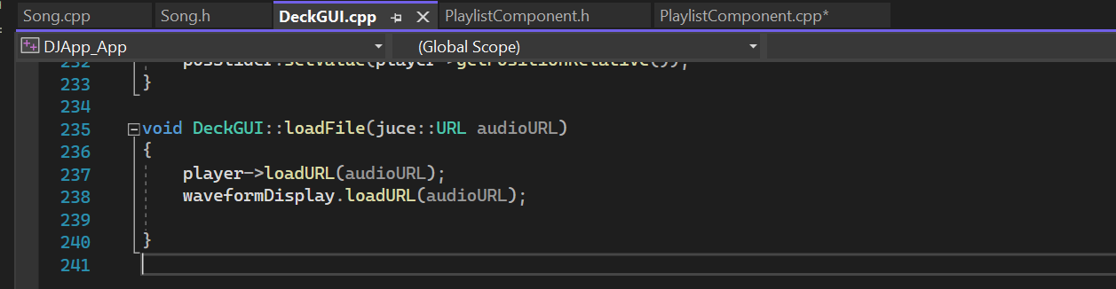

Figure 6 - DeckGUI::loadFile(juce::URL audioURL)

### R1B: playing 2 tracks at the same time

The DJAudioPlayer class is responsible for loading the song URL, setting the readerSource (l. 56, Figure 7) and transportSource (Figure 7, l. 55) equal to the newly created juce::AudioFormatReaderSource unique pointer (Figure 7, line 54).

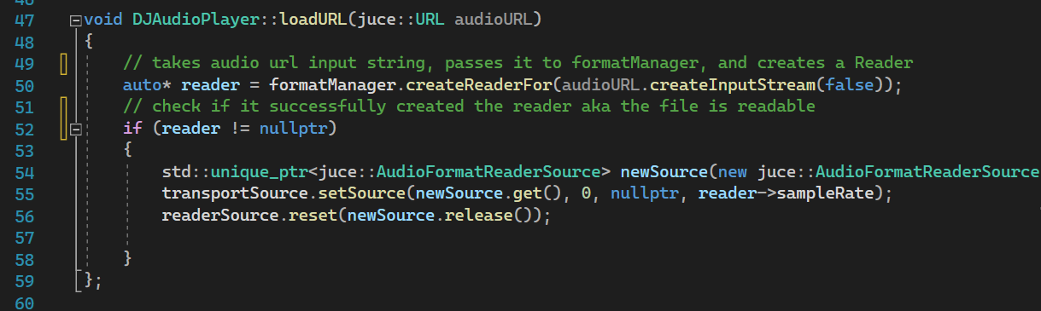

Figure 7 - DJAudioPlayer::loadURL(juce::URL audioURL)

The application creates two different DeckGUI objects, each with an autonomous DJAudioPlayer, as can be seen in Figure 8. This allows two tracks to be loaded at the same time: one on the left deck and one on the right deck.

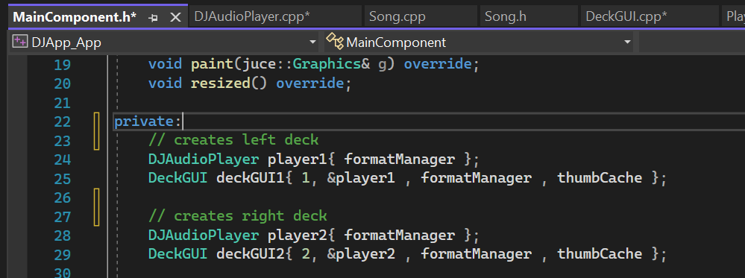

Figure 8 - MainComponent.h creates two DeckGUI objects

### R1C: Can mix the tracks by varying each of their volumes

From figure 1, we can see that each deck has a separate volume knob. Each knob is implemented as an object of class Slider, within file ‘DeckGUI.h’, line 121 (Figure 9).

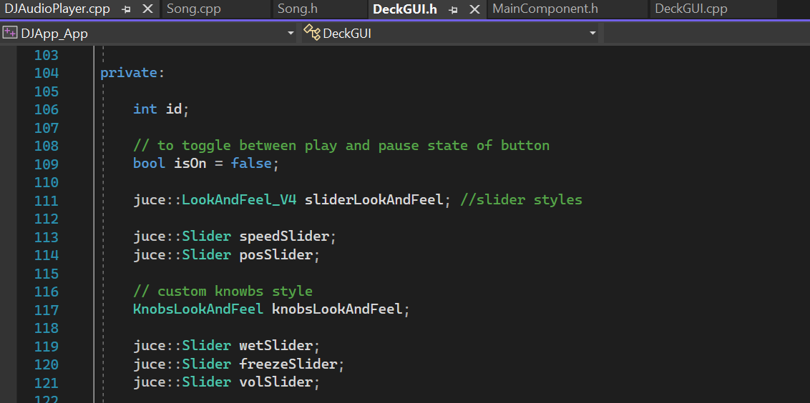

Figure 9 - DeckGUI.h, volSlider

As we have seen in figure 8, each deck is instantiated separately so as to have their own separate audio controls. Hence, the two volSlider objects (left and right deck) are separate.

Whenever the user turns the left or right volume knob, function ‘DeckGUI::sliderValueChanged’ is called. This can be found at line 184 of DeckGUI.cpp (figure 10).

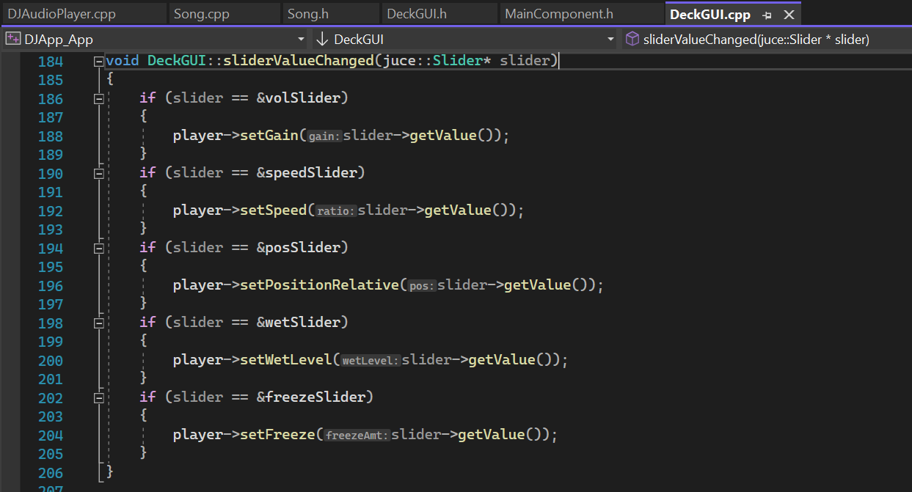

Figure 10 - DeckGUI::sliderValueChanged

This function detects which slider control was changes by the user and call a specific function accordingly. In this case, it is calling the setGain function of the deck’s player (line 188, fig. 10). Player is here the deck’s DJAudioPlayer object.

Figure 11 displays the content of setGain function. In here, method ‘setGain’ is called on the transportSource object, effectively increasing the volume of the deck’s track after checking that the gain value argument is in the inclusive range 0 to 1.

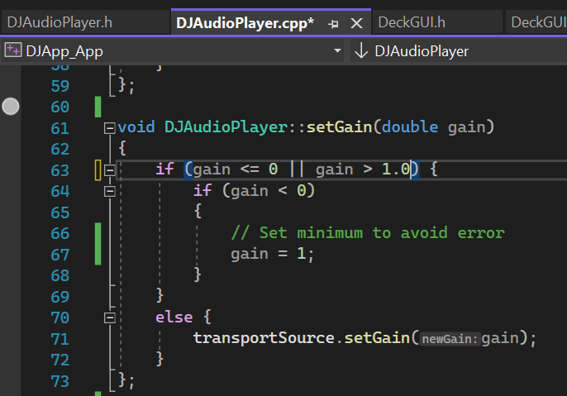

Figure 11 - DJAudioPlayer::setGain(double gain)

### R1D: Can speed up and slow down the tracks

From figure 1, we can see that each deck has a separate speed knob. Each knob is implemented as an object of class Slider, within file ‘DeckGUI.h’. The speed slider is instantiated at line 113 of figure 9.

When the user turns the speed knob, function ‘DeckGUI::sliderValueChanged’ (fig. 10) is called, entering the logic at line 192 and calling the player method’s ‘setSpeed()’.

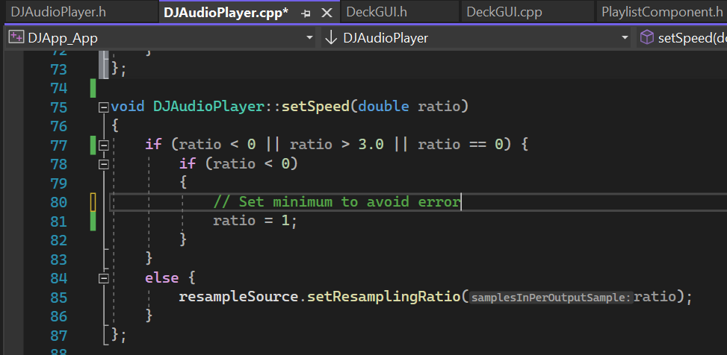

Figure 12 - DJAudioPlayer::setSpeed(double ratio)

DJAudioPlayer::setSpeed(double ratio) checks if the argument is within the accepted range 0 and 1 and if so, passes this value to the ‘setResamplingRatio’ method of the transportSource. This has the effect of speeding up or down the playback speed of the song playing on the deck, on which the speed knob is turned.

## R2: Implementation of a custom deck control Component with custom graphics which allows the user to control deck playback in some way that is more advanced than stop/ start.

I have added two custom ways in which the user can control the deck playback:

1. Right below the wave form of the track, a horizontal slider allows to play a specific relative position of the loaded track. The slider has a customized look.
2. Although not related to changing the timeline of the track, I have implemented custom graphics for the knobs on the GUI and added two extra functionalities: a knob to control wet level of the track’s reverb, and a knob to control the freeze property of the track’s reverb.
3. In addition to the play/pause button, I have added a rewind and fast forward button, with customized graphics (ImageButton).

### R2A: Components with custom graphics

1. The posSlider initialized as seen in Figure 9, line 114, is then customized in DeckGUI.cpp:

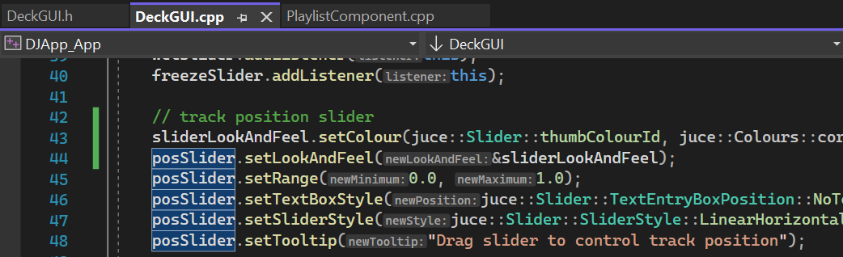

Figure 13 - posSlider custom graphics

In particular, we’re changing the slider control color to coral (fig 13, line 43).

1. The custom knobs graphic has been achieved within the KnobsLookAndFeel class, which inherits from juce::LookAndFeel_V4 and overrides the parent class method ‘drawRotarySlider’ with custom logic to display knobs images turning based on user interaction, as well as displaying a different color depending on the knob position (e.g. min volume = green, max volume = red).

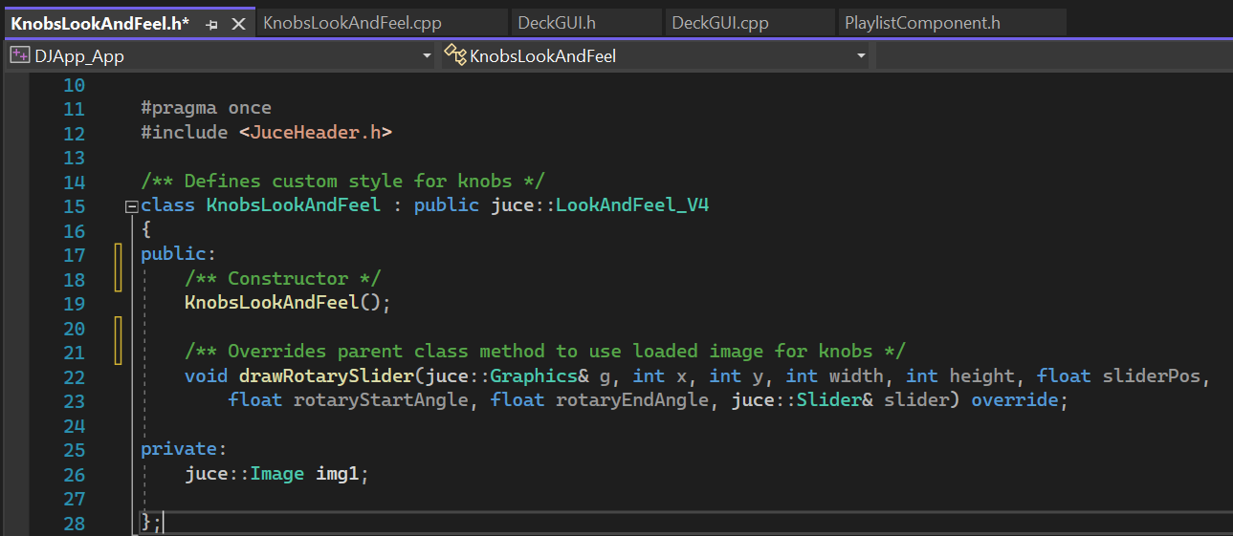

Figure 14 – KnobsLookAndFeel

1. In the private section of DeckGUI.h, three image buttons are instantiated and filled with the respective images: play, fast forward, and rewind.

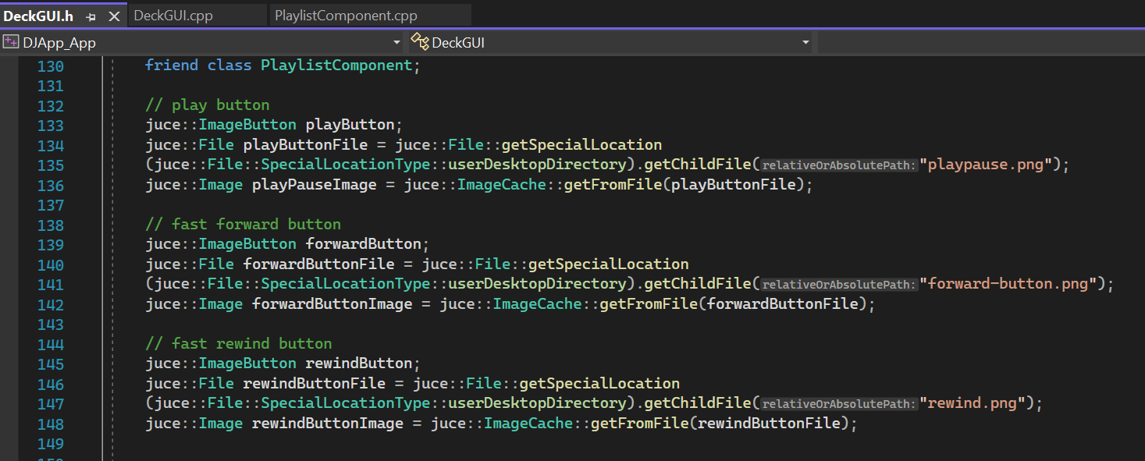

Figure 15 - track controls – ImageButtons

### R2B: Component enables the user to control the playback of a deck somehow

1. The fast forward and rewind buttons, when clicked upon, trigger the execution of lines 168-170 and 176-179 respectively (figure 16). Here, the relative position of the track is incremented / decremented by 0.05, having the effect of jumping to a future track point or previous point respectively.

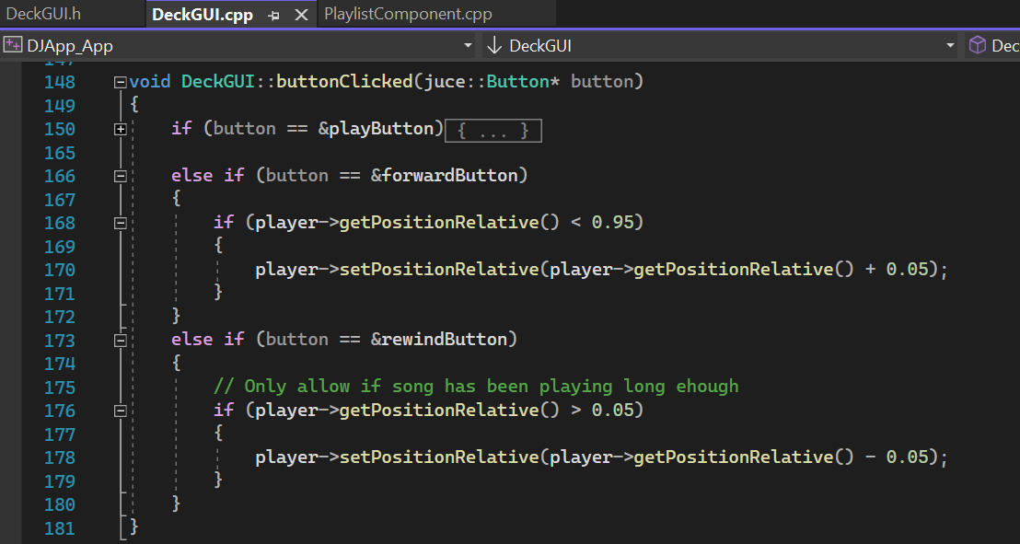

Figure 16 - buttonClicked - fast forward and rewind

1. Reverb modifications. Wet level and freeze knobs.

At lines 198 and 202 of Figure 10 we can see that when a user turns the wet knob, the player’s method ‘setWetLevel’ is called, while method ‘setFreeze’ is called by turning the freeze knowb.

In DJAudioPlayer.cpp we can find the implementation of these functions:

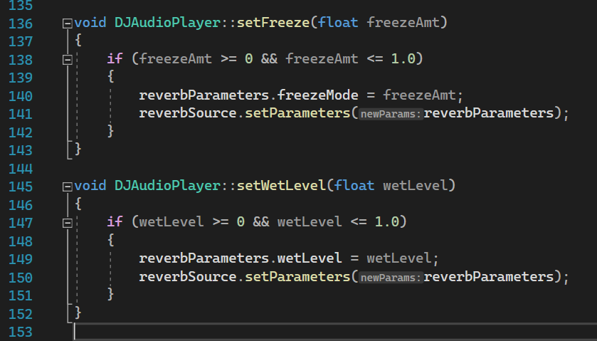

Figure 17 - reverb modifications

These function alter the track reverb and thus modify the audio output. A high ‘wet level’ makes the song sound very ‘metallic’, while the freeze knob will keep looping the song at the moment it was turned (even when the song is paused or stopped), allowing for nice track mixing effects.

1. The posSlider (horizontal slider below the track’s waveform display) can be controlled by changing the relative position of the track that is playing. Figure 10, line 196 displays that whenever the slider’s position is changed, function ‘setPositionRelative’ is called, which changes the track’s relative position.

## R3: Implementation of a music library component which allows the user to manage their music library

A music library component is added to the app via the class PlaylistComponent, which interface can be found in the file PlaylistComponent.h and which implementation can be found in the file PlaylistComponent.cpp.

### R3A: Component allows the user to add files to their library

All the functionality of the playlist is handled by the playlistComponent class, including the visual components. An object of the playlist component is created as a private attribute within the MainComponent.h file (figure 18, line 90).

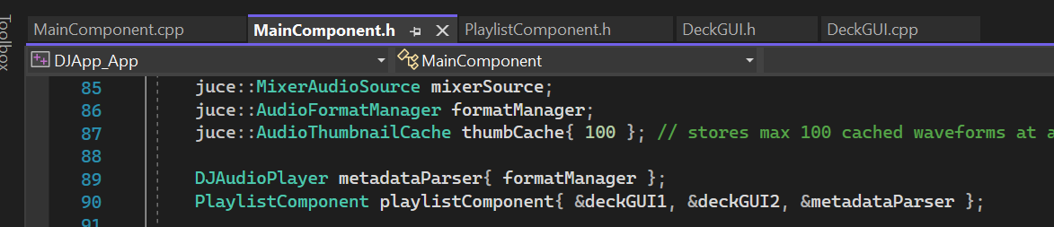

Figure 18 - PlaylistComponent object creation

The playlist component is then rendered within MainComponent.cpp (l. 24, figure 19).

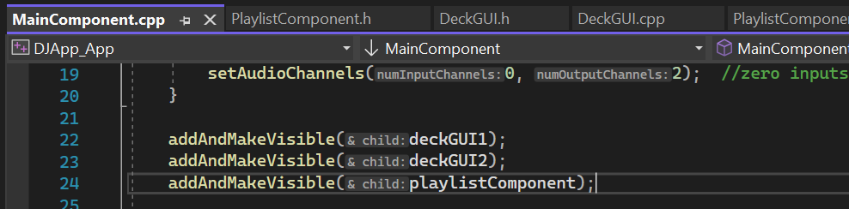

Figure 19 - rendered playlistComponent

Within MainComponent::resized(), the playlist’s bounds are also defined.

Within PlaylistComponent.h, object importSongsButton is creates as instance of the class TextButton.

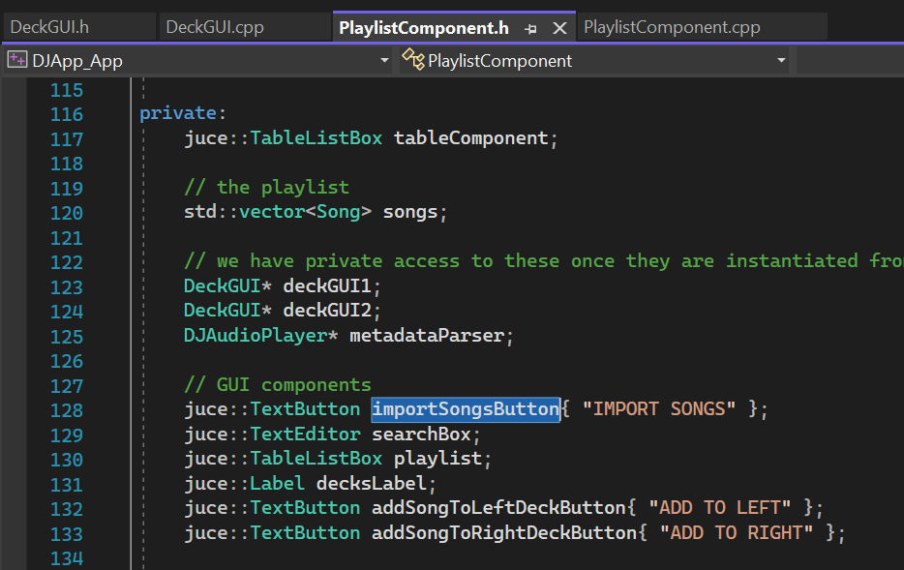

Figure 20 - creation of import songs button

The button’s position, settings are then defined within PlaylistComponent.h, in which a listener is also attached to the button. Thanks to this listener, when the user clicks on the ‘Import songs’ button, the function buttonClicked is called, executing in this case the logic at lines 170 and 171 (fig. 21).

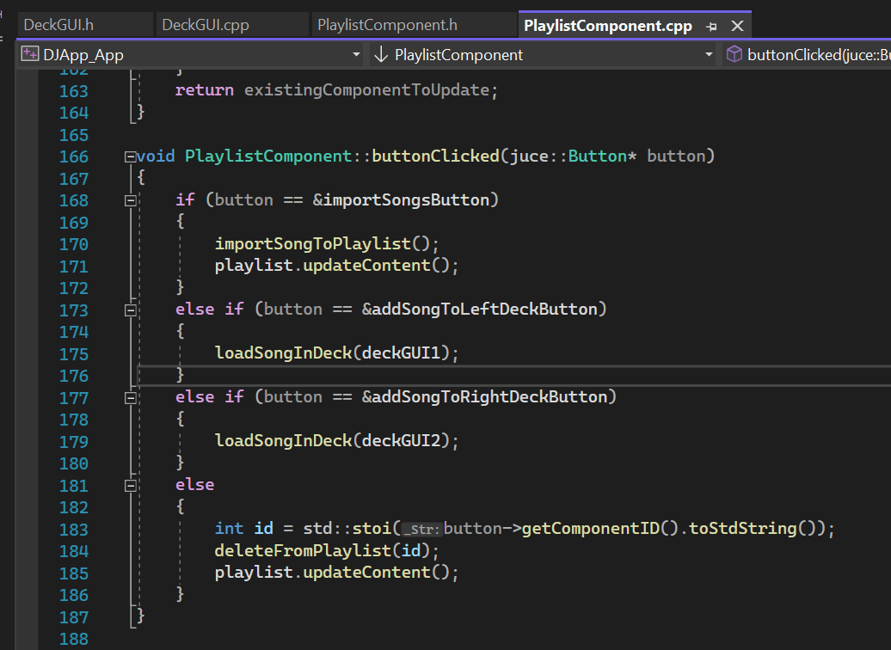

Figure 21 - playlist button clicked

Figure 22 displays function PlaylistComponent::importSongToPlaylist(). The function instantiates a Juce FileChooser object (line 241) called ‘chooser’. We can then call the method ‘browseForMultipleFilesToOpen()’ on this object, which allows the user to select multiple files from their local drive. For each file chosen, we get the file name without extension and check if the song was already saved to the playlist. If this is the case, a warning message is displayed to the user. Otherwise, the song is loaded to the playlist. This is achieved by creating an object of class Song, passing the file as argument to the constructor, then creating an audioURL object also passing the file to the class constructor (audioURL object is used to assign the track duration to the song object). Finally, we add the new song object to the playlist, which is effectively an array of Song objects called songs (line 253, fig. 22).

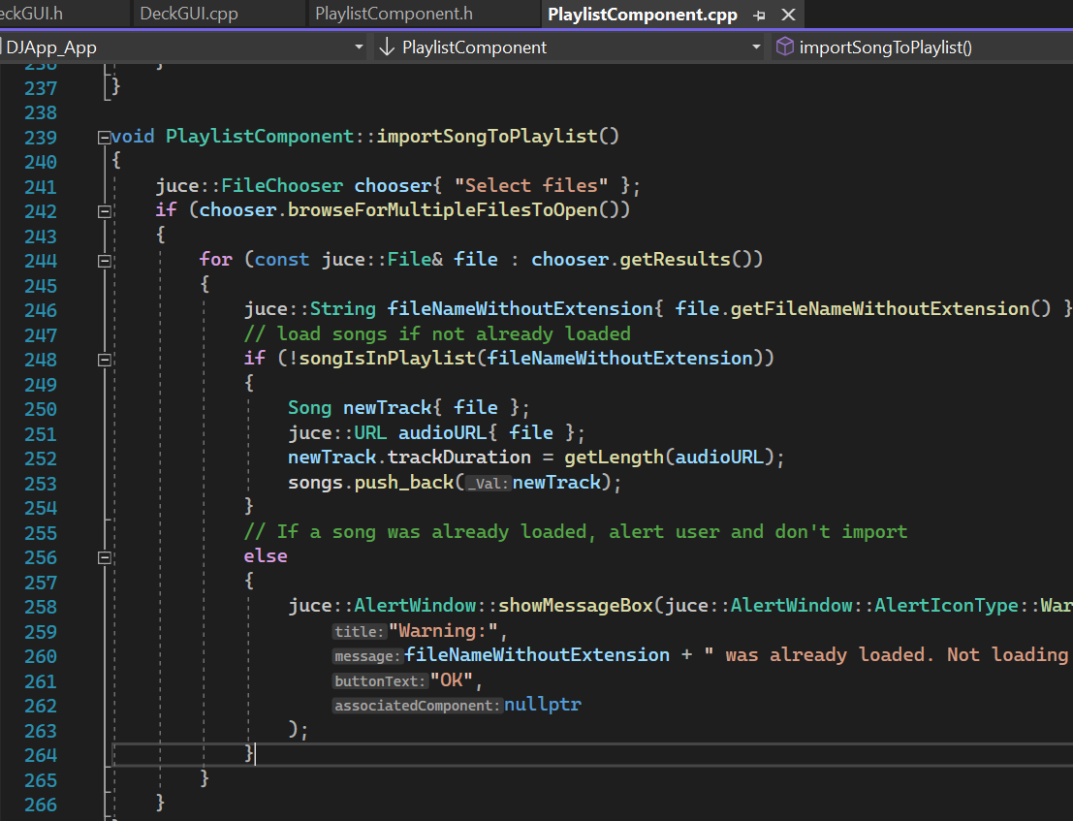

Figure 22 - PlaylistComponent::importSongToPlaylist()

### R3B: Component parses and displays meta data such as filename and song length

As we have seen above, each song is loaded to the playlist as a song object, which has the following properties: songName and trackDuration (figure 4). Attribute trackDuration is set at line 252 in fig 22, while the song name is saved when the Song constructor is run with the file as argument.

Function PlaylistComponent::getLength (fig. 23) parses the file metadata making use of the audioURL.

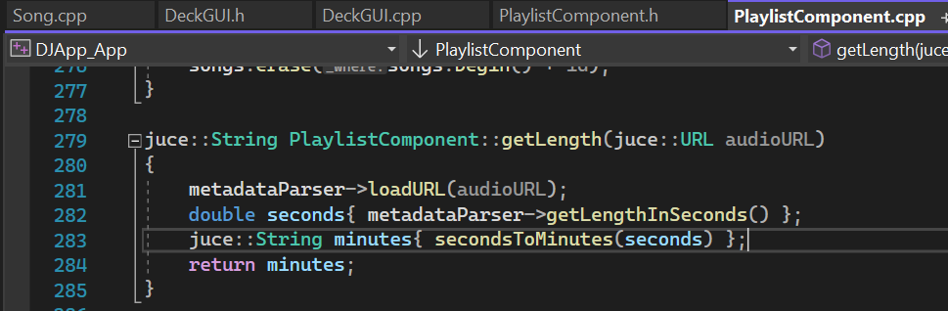

Figure 23 - get track length

Song length and track names are then displayed on the GUI thanks to function PlaylistComponent::paintCell (figure 24).

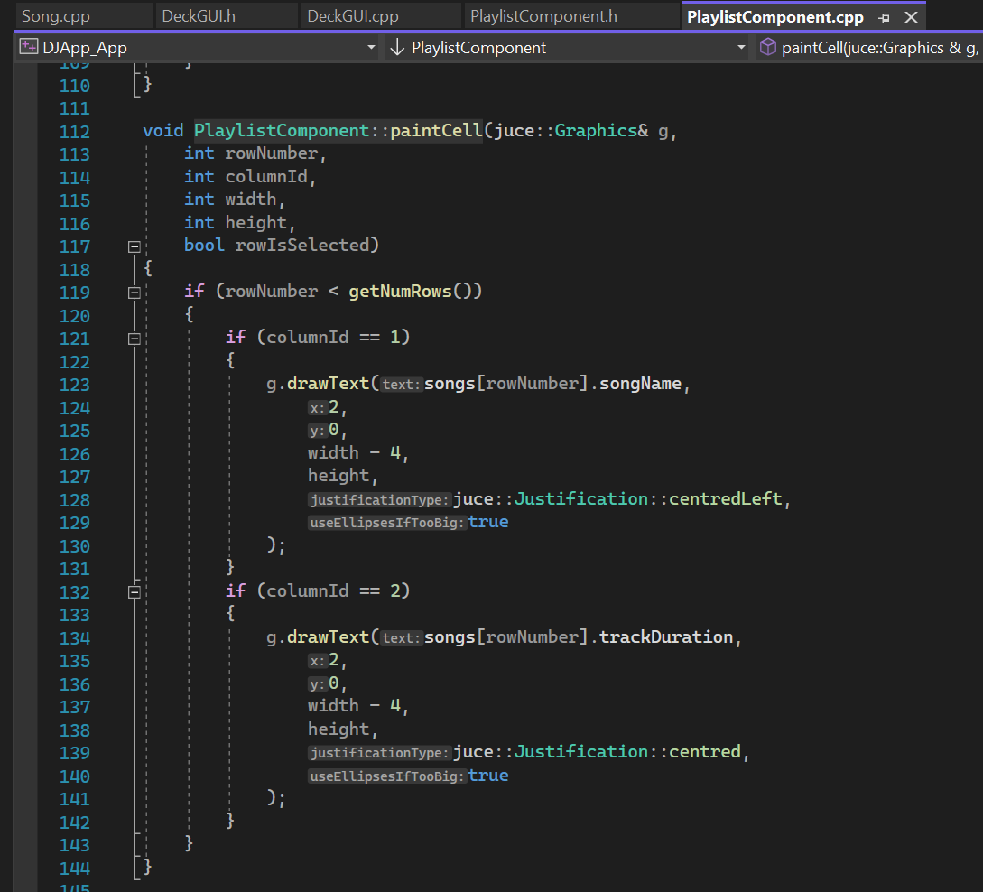

Figure 24 - PlaylistComponent::paintCell

painCell() paints a row for each song within the playlist at the center of the GUI. For each song, it displays the track name and duration.

### R3C: Component allows the user to search for files

Figure 20, line 129 displays the creation of the searchBox object, which is an object of class juce::TextEditor.

Within PlaylistComponent.cpp, we set function ‘searchPlaylist’ to be called every time the return/ enter button is pressed (figure 25, line 31). So when the user types something in the search bar at the top of the playlist, the text typed by the user is passed as argument to the searchPlaylist function.

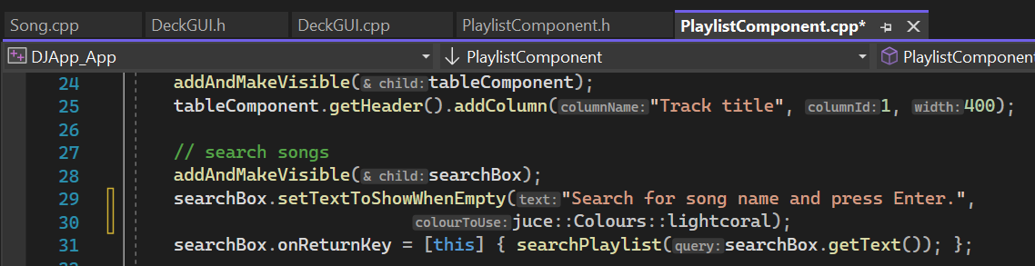

Figure 25 - searchPlaylist function trigger

Figure 26 displays the content of the searchPlaylist function. If the user did not type anything, all rows of theplaylist are deselected. Otherwise, the song name is searched via the ‘whereInPlaylist’ function, which returns the index corresponding to the songs array position where the song title is found. If no match is found, -1 is returned. The row containing the song searched by the user is highlighted (background of the cell is painted in coral color).

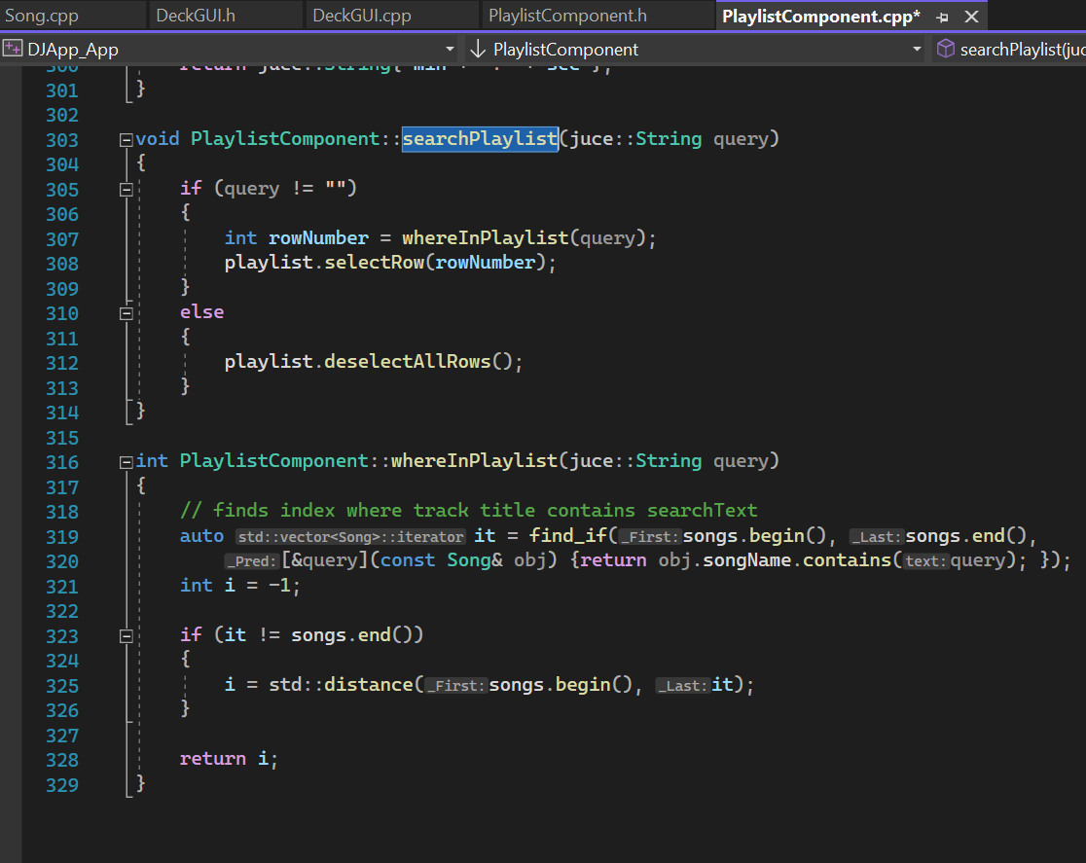

Figure 26 - searchPlaylist and whereInPlaylist functions

### R3D: Component allows the user to load files from the library into a deck

As we can see in Figure 20, two instances of class juce::TextButton are created within PlaylistComponent at lines 132 and 133: addSongToLeftDeckButton and addSongToRightDeckButton. Within PlaylistComponent.cpp, at lines 57 and 58 a listener is attached to each button. Thanks to this listener, function loadSongInDeck is called every time the user clicks on any of these buttons (lines 175 and 179, Figure 21). loadSongInDeck is called passing as argument the deck to which we’re adding the song.

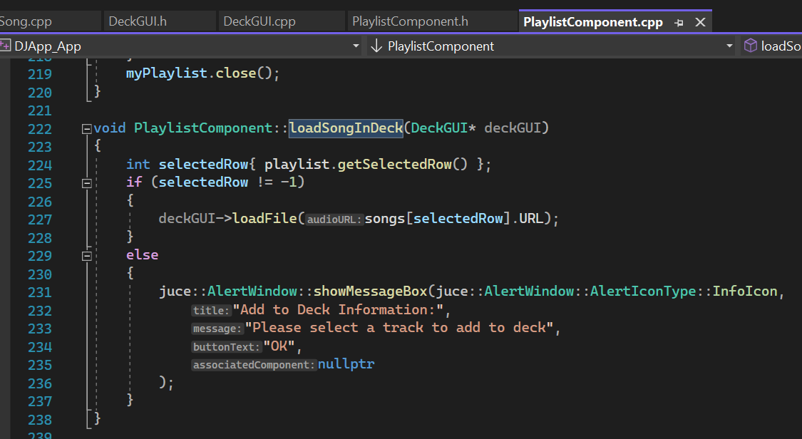

Figure 27 - PlaylistComponent::loadSongInDeck

Figure 27 shows the content of this function. If the user has selected a song from the playlist and then clicked on the ‘add to left’ or ‘add to right’ buttons, the song will be loaded to the corresponding deck. Otherwise, a warning message tells the user to select a song before clicking these buttons.

After selectin a song from the playlist either by mouse click or by search, the user can add it to either DeckGUI by using a button like “Add to left” or “Add to right”.This will call the **loadInPlayer()** function circa ln 259 in **PlaylistComponent.cpp**. It takes a DeckGUI object as a parameter, searches the playlist’s rows for which is the currently selected song and calls the DeckGUI’s **loadFile()** function by passing the Song’s URL. If no song is selected, the user will see a prompt window.

### R3E: The music library persists so that it is restored when the user exits then restarts the application

A function **savePlaylist()** is defined circa ln219 in PlaylistComponent.cpp which saves a .csv file on the user’s PC. Then for each Song object in the songs vector, it will save the path to the file and the length of the song in the **.csv**.

When the user closes the JUCE app and the PlaylistComponent is destroyed, in **~PlaylistComponent()** circa ln62 in PlaylistComponent.cpp, it calls the **savePlaylist()** function.

When the user start up the app again and PlaylistComponent is instantiated, **loadPlaylist()** is called circa ln45. **loadPlaylist()** is defined circa ln.234 in **PlaylistComponent.cpp**, it opens the .csv created from **savePlaylist()**, reads each line and loads each File by passing in the file path. This way all Song objects are again pushed into the **songs** vector and the playlist is available to the user again.

## Implementation of a complete custom GUI

A complete custom GUI is created for the app. Components’ layout is changed, new components added, button and slider styles are changed, main colour scheme is changed.

### GUI layout is significantly different from the basic DeckGUI shown in class, with extra controls

These are some initial sketches and design drafts of how to layout the complete app.

The initial idea was to have one AxisModificator component for each DeckGUI. However, this idea lates changed to having 2 AxisModificators as it turned out JUCE offered several reverb variables to use which allowed this. This first design also did not leave any space for sliders so it needed reworking.

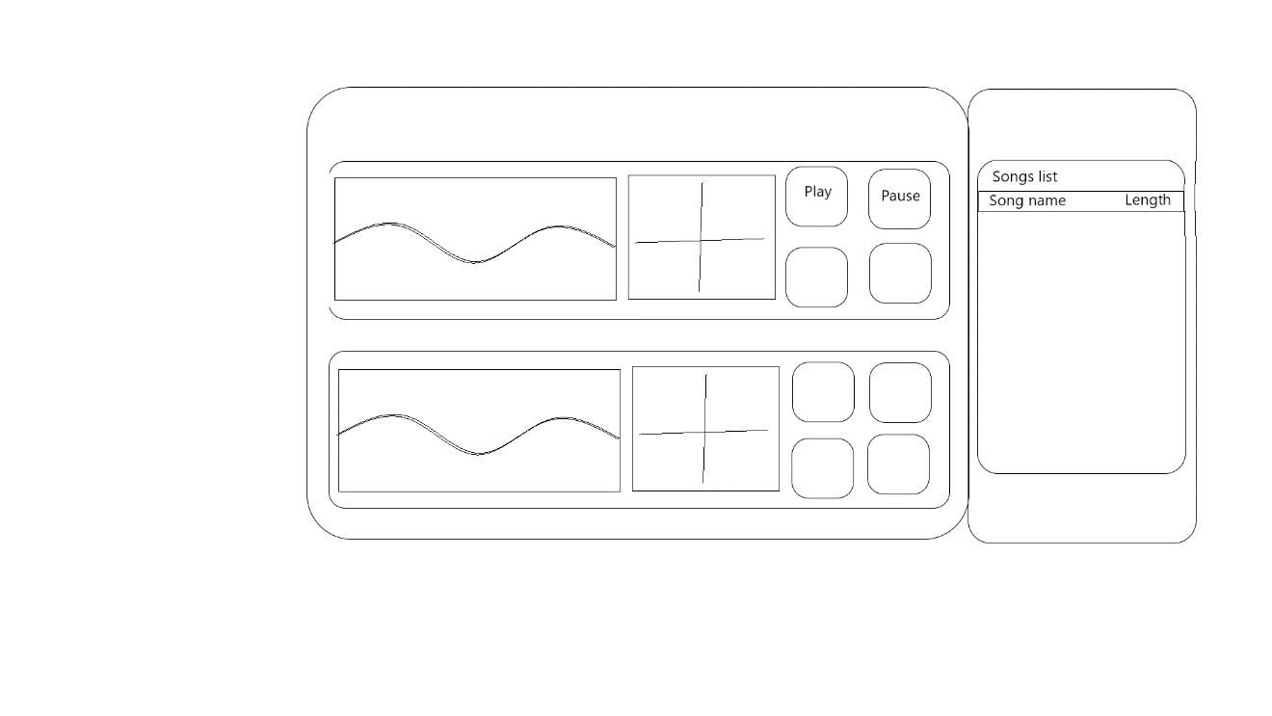

Then the second draft accommodated sliders and two AxisModificators per DeckGUI.

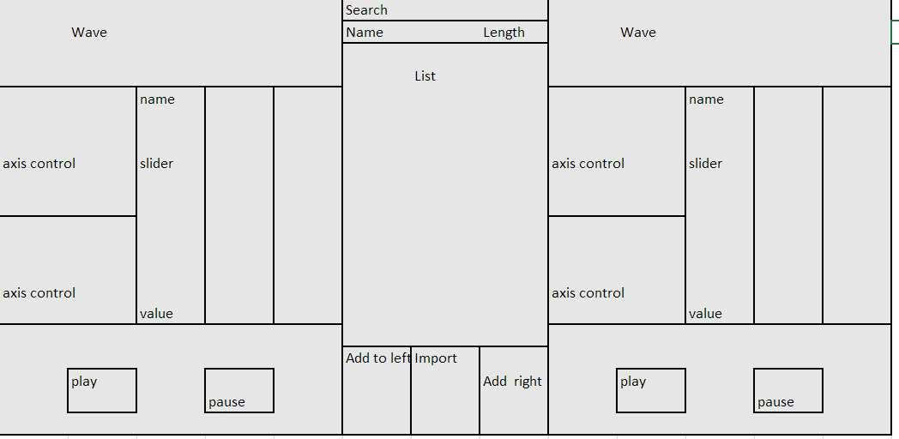

The third draft attempted to split out the width and height “cells” each component would take up. Colour-coding and writing the X and Y values for size of each component would make planning easier.

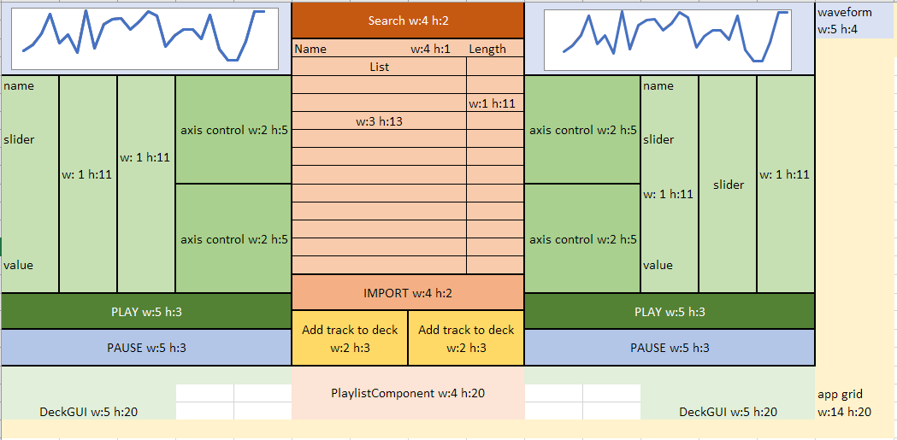

After having this third draft, it took some user testing and participant feedback to receive some ideas for changes.

The final design implemented “forward” and “backward” button in each DeckGUI, and also a Playback progress bar which users can use to control where the song plays. The AxisModificators are put horizontally together and under them would be two sliders, one of which made rotary. This provided a variety of visual components and made the UI interesting and engaging. The participants were then happy with the final results.

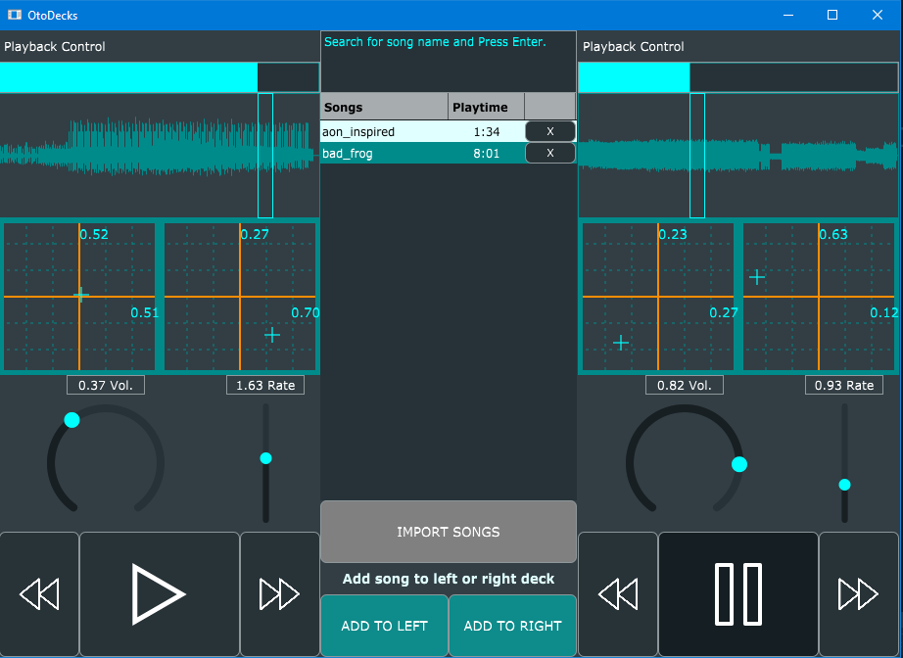

The main colour scheme is made to follow around nuances of cyan.

One of the sliders is made into a Rotary style circa ln.81, and the PlaybackBar mentioned earlier is a more advanced way of styling a Slider.

The Buttons are changed from **TextButton**s into **DrawableButton**s. Drawables are created to load the required .svg images for the button icons. Drawables and DrawableButtons are created circa ln.37 in **DeckGUI.cpp**. The Play button is now checking the state of the player and if it is playing, the Play button turns into a Pause button. Checking whether the button should start or pause the song is done in **buttonClicked()** circa ln.158 in particular. A Boolean called **isOn** is used for this purpose.

## Summary

The JUCE app is an amazing project to work since it allows fun testing and debugging during development. The JUCE framework is a unique way of learning Object Oriented Programming since it offers up GUI and Audio processing while also requiring a good understanding of SOC, Inheritance, overloading and polymorphism.